Warning – Cold Start Reservoir Low (Brazil markets only) – CGEA1.3

Functional Description

The purpose of the Cold Start Reservoir warning is to inform the driver the vehicles cold start reservoir is low and needs to be re-filled. The cold start reservoir contains a starting fluid required for 100% ethanol applications.

The Cold Start Reservoir Warning Function correlates the EcssLamp_D_RqDsply signal from the PCM and the operational mode to display the appropriate warning in the message center.

Interfaces

Interface Context Diagram (I/O Block Diagram)
Figure 1 Warning – Adaptive Headlamps Context Diagram
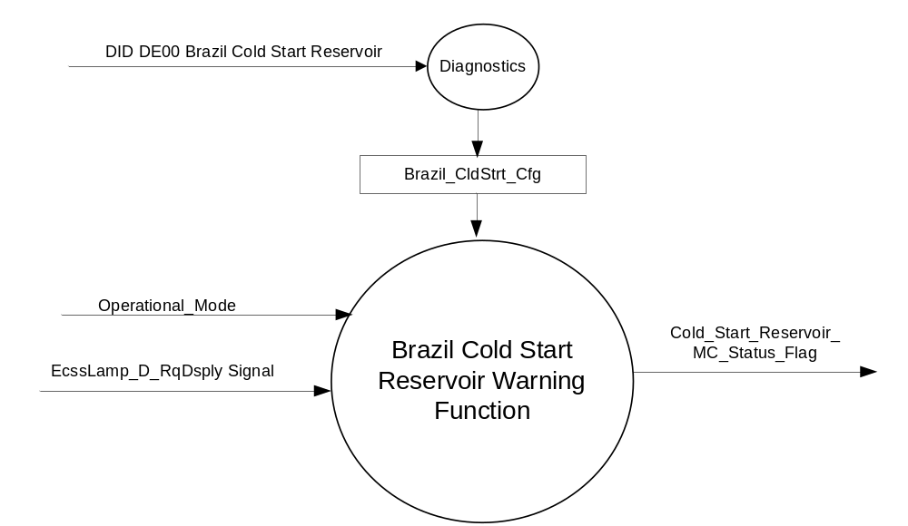

Inputs
      - INTERNAL:
            - Operational_Mode
            - Brazil_CldStrt_Cfg
- MUX message from the CAN bus

- Adaptive_Hdlmp_Fault Signal
Signal Name | Size  (bits) | Detail | Units | Res. | Offset | State  Encoded | Min | Max
EcssLamp_D_RqDsply | 2 |  | SED | 1 | 0 |  | 0 (0x0) | 3 (0x3)
 |  | Off |  |  |  | 0x0
 |  | On |  |  |  | 0x1
 |  | Flash |  |  |  | 0x2
 |  | Not_Used |  |  |  | 0x3

Outputs
Cold_Start_Reservoir_MC_Status_Flag that is used to control the Warning displayed in the
message center.

Function/Performance

Operational Modes

Mode | Differentiating Vehicle Conditions
Sleep Mode | OFF
Limited Mode | OFF
Normal Mode | Brazil Cold Start Reservoir Warning Function Text Messages OFF/ON
Crank Mode | Brazil Cold Start Reservoir Warning Function Text Messages OFF / ON

The above table references the setting of the Warning flag as per this section. However, the actual Warning display operational modes are displayed in the Message Center section of this SPSS.

Voltage Levels

Refer to the Cluster Features Table located in the Operational Modes and Voltage Range Strategies Section of this SPSS

Human-Machine Interface

Visual

Indicator Graphics / Display Format

Refer to Message Center Function description reference "BEF Display 2x14 Text Message List.xls" file Message ID W2045

1.3.3.1.2 Indicator Color Coordinates

Reference section COLOR & ILLUMINATION REQUIREMENTS (GRAPHICS)

1.3.3.1.3 Indicator Characteristics

Refer to Message Center X Display_Y Button Interface Section, where X and Y are appropriate values in this document.

Audio

No Message Center Warning Chime is associated with this Warning.

Switch Control Logic

Consumer access to Brazil Cold Start Warning shall be as specified in the message center basic functionality display as specified in Message Center X Display_Y Button Interface Section, where X and Y are appropriate values in this document.

System Accuracy

Within 100 msec of receiving a message that results in a change of state the cluster will update the display to the proper state.

Operation: Performance and Functional

Subsystem Algorithm Flowchart / State Diagram

- State Matrix for Warning – Cold Start Reservoir
Operational_Mode | Brazil_CldStrt_ Cfg | EcssLamp_D_RqDsply | Cold_Start_Reservoir _MC_Status_Flag
Normal / Crank | Enabled (0x1) | On (0x1) | ACTIVE
Normal / Crank | Enabled (0x1) | Missing as per 1.4.1 | INACTIVE
All Other Cases |  |  | INACTIVE

- Cold Start Reservoir MC Status Flag to MC Warning Message IF
Cold_Start_Reservoir _MC_Status_Flag | MC Warning Message ID | Audible
Inactive | None | None
Active | W2045 | None

Operation Description (supports algorithm flowchart /state diagram)

- When Cold_Start_Reservoir_MC_Status_Flag is active then W2045 shall be ACTIVE.
- For definition of how the Message Center arbitrates and displays Active warnings, see the Warning / Alert Display Logic Diagram, located in the Message Center – X Display with W Button Interface section of this SPSS (where X and W are appropriate values in this document).

Function Safety Classification (EMC)

Class B

Memory Storage

Parameter Name | Description | Value at  Battery Connect | Value at  Module Wake-up
Cold_Start_Reservoir_MC_Status_Flag | Used to control the state of the warning to the Message Center arbitrator | INACTIVE (0x0) | INACTIVE (0x0)
Brazil_CldStrt_Cfg | Configures cluster to enable / disable Cold Start Reservoir Warning. | Use Stored Value | Use Stored Value
EcssLamp_D_RqDsply Signal | Input signal sent from the PCM to the IC | Off (0x0) | Off (0x0)
Operational_Mode | 4 state indicator for cluster operational mode | Limited | Limited or Normal or Crank

Prove Out

No.

Reconfigurable Telltale

No.

Message Center Msg

Refer to Message Center Function description reference Global Text Message List.xls" file Message ID W2045

Error Handling

Missing Message/Undefined Data Strategy

The signals will be declared missing as per the Diagnostics section of this SPSS.

DTCs states and history will be determined as per the Diagnostics section of this SPSS.

If the Brazil_CldStrt_Cfg is DISABLED, the cluster shall never log a missing message DTC due to this feature.

Diagnostics

Self Test

None

Engineering Test Mode

Reference section “Dealer / Engineering Test Mode (ETM)”

Part II Performance

Supported Diagnostic Trouble Codes (DTCs)
DTC | Description
C10000 | Lost communication with ECM/PCM

Mod Conf (DID DE00)
Block  Num | Block Description | Byte(s) | Bits | State: Description | "0" | "1" | Default | Comments/Information
PACKETED BLOCKS
$00 | Option Content (B&A) | * | * | Brazil Cold Start Reservoir | Disabled | Enabled | Disabled
*Byte and bit location to be identified in Part II Specification for this cluster

Reference Specification

IS-0001 WARNINGS/INDICATORS/DISPLAYS PROVEOUT
IS-0052 OPERATING VOLTAGES - FUNCTIONAL/PERFORMANCE
IS-0069 FUNCTIONAL IMPORTANCE CLASS
IS-0324 WINDSHIELD & OTHER REFLECTIONS
IS-0327 WARNING INDICATOR EVALUATION
IS-0379 NORTH AMERICAN WARNINGS AND INDICATORS STRATEGY

IL-0017 TELLTALE AND INTERIOR ILLUMINATION – COLOR AND INTENSITY
IL-0019 GENERAL ILLUMINATION DIMMING
IL-0021 CRAFTSMANSHIP – DISPLAYS
IL-0022 GENERAL ILLUMINTATION COLOR
IL-0023 CLARITY/LEGIBILITY/READABILITY/VISUAL CONTRAST
IL -0043 OPERATIONAL ENVIRONMENT FUNCTIONALITY
IL -0045 COLOR
IL -0047 TELLTALE, INDICATOR AND DISPLAY LIGHT INTENSITY
IL -0048 ILLUMINATION ACCEPTABILITY

03-0661 PLACEMENT: CONTROL AND DISPLAY LOCATIONS
03-0662 PLACEMENT: LOGICAL GROUPING FUNCTION AND USAGE
03-0664 PLACEMENT: DOWN VISION TO COMPONENTS WITH HIGH VISUAL DEMAND
03-0665 PLACEMENT: EXPECTED LOCATIONS OF CONTROLS AND DISPLAYS VDS
03-0670 INTERIOR VISIBILITY
03-0671 INTERIOR VISIBILITY: REFLECTIONS FROM COMPONENTS & SURFACES
03-0672 INTERIOR VISIBILITY: REFLECTIONS IN DISPLAYS
03-0673 INTERIOR VISIBILITY: VISUAL OBSCURATIONS
03-0674 INTERIOR VISIBILITY: ILLUMINATION CONTROLS / DISPLAYS
03-0675 INTERIOR VISIBILITY: VEILING GLARE
03-0677 INTERIOR VISIBILITY: SUNLIGHT WASHOUT
03-0681 IDENTIFICATION: CHARACTER AND SYMBOL SIZE
03-0682 IDENTIFICATION: LEGIBILITY
03-0685 IDENTIFICATION: SYMBOLS, ABBREV FOR CONTROL
03-0721 LOGIC OF OPERATION: OPERATIONAL STEREOTYPES
03-0722 LOGIC OF OPERATION: INTERPRETATION
03-0723 LOGIC OF OPERATION: USE OF SYSTEMS WITH VISUAL DISPLAYS

Revision History

SPSS Module Revision History

Revision Level | Name | Change Description | Date
1.0 | Jblatchf | Initial release. Warning message approved in 9/20/12 DI Change Control. SC* warning message type chosen to allow warning display time to be extended from current 10s display time based on local market wants. PCM controls duration of message display. Implemented in Brazil markets only. Note: 9/20/12 email from Stavros Dionyssopoulos defines message as SC* / no chime. | 9/28/12
1.1 | JBlatchf | 1.3.3.4: Changed feature as called out to Brazil Cold Start Warning. v1.0 intent was clear so recommend new program or initial DCR only. | 10/1/12

